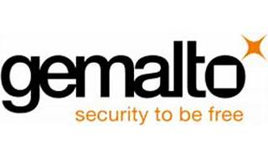

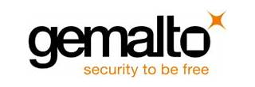

Explore

**Gemalto** is a global digital security company that provides a wide range of products and services to help organizations and individuals secure their digital identities, data, and transactions. [Their solutions include encryption, authentication, identity and access management, secure payment technologies, and more1](https://www.devopsschool.com/blog/what-is-gemalto-and-use-cases-of-gemalto/).

Here are **five reference links** where you can learn more about Gemalto’s offerings:

1. [**Digital Identity and Security - Gemalto**](https://www.thalesgroup.com/en/markets/digital-identity-and-security): Explore their advanced digital capabilities, including identity management, data protection, and secure services[2](https://www.thalesgroup.com/en/markets/digital-identity-and-security).
2. [**Your Tech Story - Gemalto**](https://www.yourtechstory.com/2021/06/22/gemalto-a-renowned-digital-security-company-recently-purchased-by-the-thales-group/): Learn about Gemalto’s history, products, and services in the digital security sector[3](https://www.yourtechstory.com/2021/06/22/gemalto-a-renowned-digital-security-company-recently-purchased-by-the-thales-group/).
3. [**DevOpsSchool - What is Gemalto and use cases**](https://www.devopsschool.com/blog/what-is-gemalto-and-use-cases-of-gemalto/): Dive into use cases and understand how Gemalto contributes to securing digital interactions[1](https://www.devopsschool.com/blog/what-is-gemalto-and-use-cases-of-gemalto/).
4. [**E-Tech Components - Gemalto**](https://etechcomponents.com/brands/gemalto/): Discover their wireless modules for cellular Machine-to-Machine (M2M) communications[4](https://etechcomponents.com/brands/gemalto/).
5. [**Wikipedia - Gemalto**](https://en.wikipedia.org/wiki/Gemalto): Get an overview of Gemalto’s background, products, and services[5](https://en.wikipedia.org/wiki/Gemalto).

Feel free to explore these resources to enhance your understanding of Gemalto’s role in the tech industry! 🌐🔒